

Amazon.COM Announces 21% SALES GROWTH Driven by lower prices and expanded selection; raises financial guidance

SEATTLE—(BUSINESS WIRE)—July 23, 2002—Amazon.com, Inc. (NASD: AMZN) today announced financial results for its second quarter ended June 30, 2002.

Free cash flow was $16 million for the trailing four quarters, compared with negative $270 million for the four quarters ended June 2001. Free cash flow includes interest payments and capital expenditures and excludes proceeds from exercise of stock options.

Common stock outstanding was 380 million shares at June 30, 2002, an increase of 5% compared to June 30, 2001 (approximately half of the increase was in connection with a July 2001 $100 million investment in the Company).

Net sales were $806 million, compared with $668 million in the second quarter 2001, an increase of 21%.

Operating profit was $1 million, compared with a loss of $140 million a year ago. Pro forma operating profit was $26 million, or 3% of net sales, exceeding the Company’s guidance of $5 million to $15 million. This compares with a pro forma operating loss of $28 million in the second quarter 2001, an improvement of $54 million.

Net loss was $94 million, or $0.25 per share, compared with a second quarter 2001 net loss of $168 million, or $0.47 per share. Pro forma net loss, which includes interest expense, was $4 million, or $0.01 per share, compared with a pro forma net loss of $58 million, or $0.16 per share, in the second quarter 2001. (Details on the differences between GAAP results and pro forma results are included below, with a tabular reconciliation of those differences included in the attached financial statements.)

“I’m especially pleased with the outstanding job our U.S. Books team is doing—posting another quarter of 20% year-over-year book unit growth, up from 15% growth this past fourth quarter,” said Jeff Bezos, founder and CEO of Amazon.com. “Also, Electronics, Tools and Kitchen revenues accelerated as we lowered prices and expanded Electronics selection by 40% to over 60,000 items, including products from Sony, Toshiba, Yamaha and Microsoft.”

In June, Amazon.com announced its fourth significant price decrease in the past year. In July 2001, the Company lowered book prices to 30% off books over $20, and in January introduced its Free Super Saver Shipping option on orders over $99. In April, Amazon.com extended the 30% discount to books over $15, and in June extended its Free Super Saver Shipping option to qualifying orders over $49 as a long-term test. Additionally, Amazon.com recently reduced prices on electronics, tools and many bestselling CDs and DVDs.

Highlights of Second Quarter Results (comparisons are with the equivalent period of 2001)

- Third-party transactions (new, used and refurbished items sold on Amazon.com product detail pages by businesses and individuals) grew sequentially to 20% of North American units, representing 35% of North American orders, compared with 10% of units and 18% of orders.
- International segment sales, from the Company’s U.K., German, French and Japanese sites, grew 70% to $218 million, and pro forma operating results improved by 66% to a loss of $10 million, or 5% of International sales.
- Electronics, Tools and Kitchen segment sales growth accelerated to 16% from 8% growth in the first quarter 2002, and pro forma operating losses declined 55% to $18 million.
- Books unit growth was 20%. Books, Music and DVD/Video segment sales grew 6% to $412 million. Pro forma operating profit grew 26% to $49 million, a record 12% of Books, Music and DVD/Video sales.
- Pro forma operating profit was $82 million for the trailing four quarters, or 2% of net sales.
- Inventory turns improved 35% to 19 for the trailing four quarters, up from 14.

Stock Options

The Company announced that by the beginning of 2003 all stock-based awards granted thereafter will be expensed.

Financial Guidance

The following forward-looking statements reflect Amazon.com’s expectations as of July 23, 2002. Results may be materially affected by many factors, such as changes in general economic conditions and consumer spending, the emerging nature and rate of growth of the Internet and online commerce, and the various factors detailed below.

Third Quarter 2002 Expectations
- Net sales are expected to be between $780 million and $830 million.
- Pro forma operating income is expected to be between $8 million and $17 million, or between 1% and 2% of net sales.

Full Year 2002 Expectations
- Free cash flow is expected.
- Net sales are expected to grow by over 18%.
- Pro forma net income is expected.

A conference call will be Webcast live at www.amazon.com/ir today at 2 p.m. PT/5 p.m. ET and will be available through September 30, 2002. This call will contain forward-looking statements and other material information.

These forward-looking statements are inherently difficult to predict. Actual results could differ materially for a variety of reasons, including, among others, the rate of growth of the economy in general and of the Internet and online commerce; customer spending patterns; the amount that Amazon.com invests in new business opportunities and the timing of those investments; the mix of products sold to customers; the mix of net sales derived from products as compared with services; competition; risks of inventory management; the degree to which the Company enters into, maintains and develops service relationships with third-party sellers and other strategic transactions; foreign-currency exchange risks; seasonality; international growth and expansion; risks of fulfillment throughput and productivity; and fluctuations in the value of securities and non-cash payments Amazon.com receives in connection with such transactions. Other risks and uncertainties include, among others, risk of future losses, significant amount of indebtedness, potential fluctuations in operating results, management of potential growth, system interruptions, consumer trends, fulfillment center optimization, inventory, limited operating history, government regulation and taxation, customer or third-party sellers fraud, Amazon.com Payments, and new business areas, business combinations and strategic alliances. More information about factors that potentially could affect Amazon.com’s financial results is included in Amazon.com’s filings with the Securities and Exchange Commission, including its Annual Report on Form 10-K for the year ended December 31, 2001, and all subsequent filings.

The Company intends to continue its practice of not updating forward-looking statements other than in publicly available documents.

Pro Forma Results

Pro forma results, which generally exclude non-operational, non-cash charges and benefits as well as one-time charges, are provided as a complement to results provided in accordance with accounting principles generally accepted in the United States (known as “GAAP”). Management uses such pro forma measures internally to evaluate the Company’s performance and manage its operations. A reconciliation of GAAP to pro forma is included in the attached financial statements.

Pro forma operating results exclude the following line items on the Company’s statements of operations:
- Stock-based compensation,
- Amortization of goodwill and other intangibles, and
- Restructuring-related and other.

Pro forma net results exclude, in addition to the line items described above, the following line items on the Company’s statements of operations:
- Other gains (losses), net,
- Equity in losses of equity-method investees, net, and
- Cumulative effect of change in accounting principle.

About Amazon.com

Amazon.com, a Fortune 500 company based in Seattle, opened its virtual doors on the World Wide Web in July 1995 and today offers Earth’s Biggest Selection. Amazon.com seeks to be the world’s most customer-centric company, where customers can find and discover anything they might want to buy online. Amazon.com and sellers list millions of unique new and used items in categories such as electronics, computers, kitchenware and housewares, books, music, DVDs, videos, camera and photo items, toys, baby items and baby registry, software, computer and video games, cell phones and service, tools and hardware, travel services, magazine subscriptions and outdoor living items. Through Amazon Marketplace, zShops and Auctions, any business or individual can sell virtually anything to Amazon.com’s millions of customers, and with Amazon.com Payments, sellers can accept credit card transactions, avoiding the hassles of offline payments.

Amazon.com operates five international Web sites: www.amazon.ca, www.amazon.co.uk, www.amazon.de, www.amazon.fr and www.amazon.co.jp. It also operates the Internet Movie Database (www.imdb.com), the Web’s comprehensive and authoritative source of information on more than 300,000 movies and entertainment titles and 1 million cast and crew members dating from the birth of film.

Contact:

Amazon.com Investor Relations
Tim Halladay, 206/266-2171, ir@amazon.com

Amazon.com Public Relations
Bill Curry, 206/266-7180
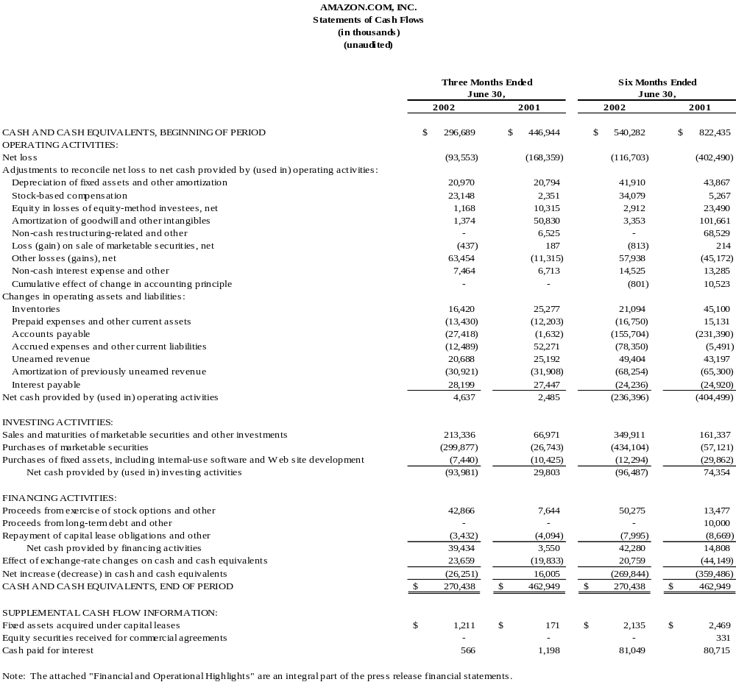
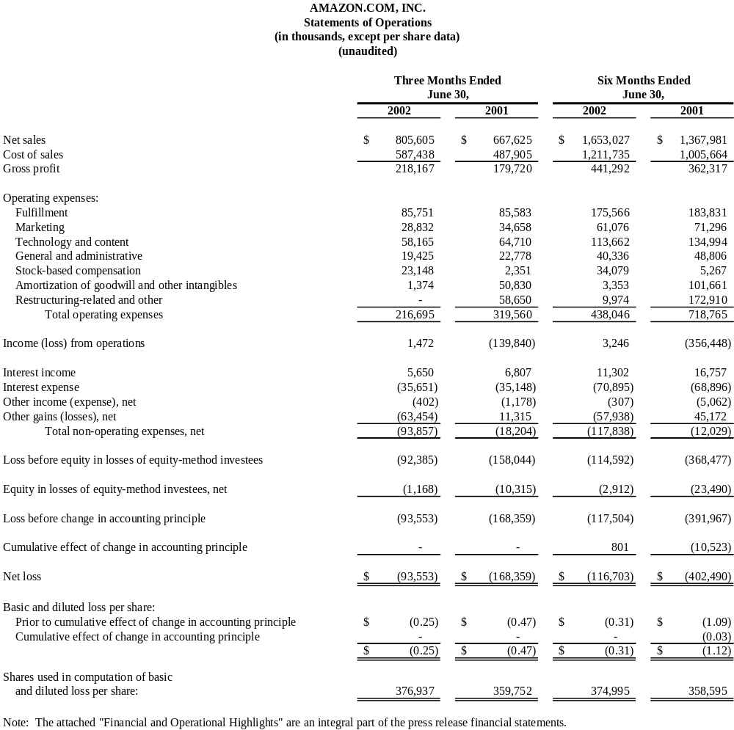
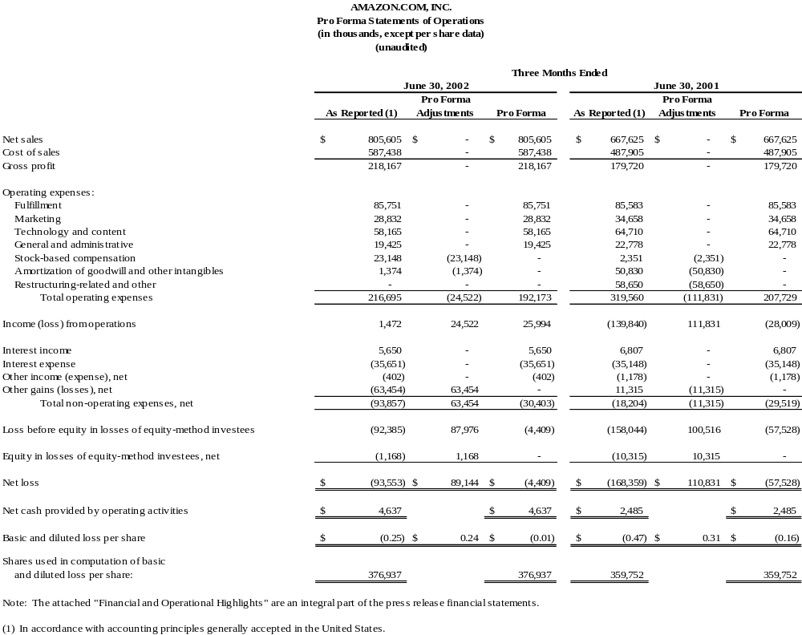
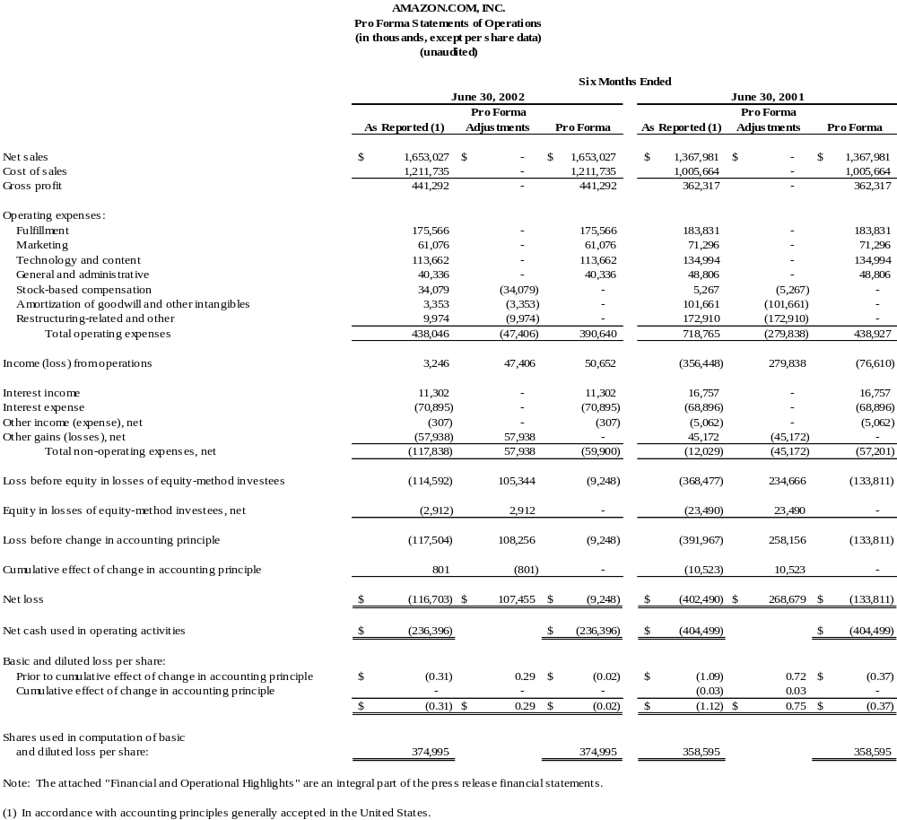
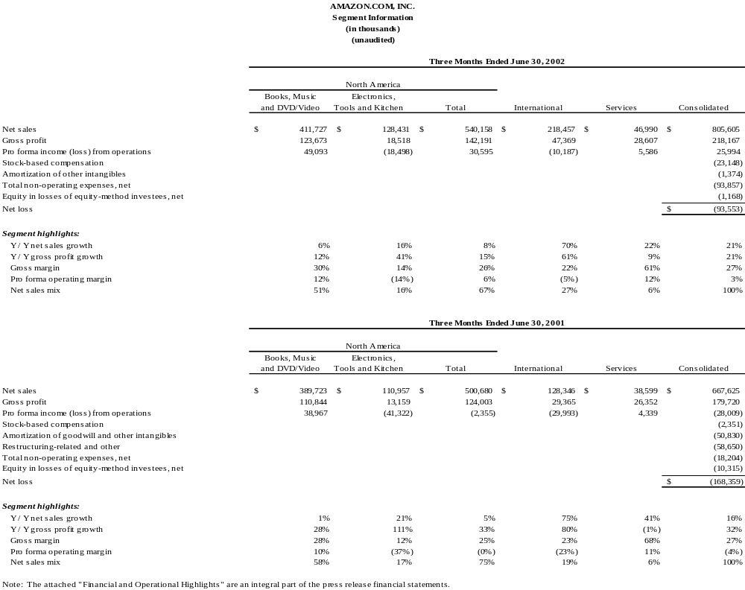
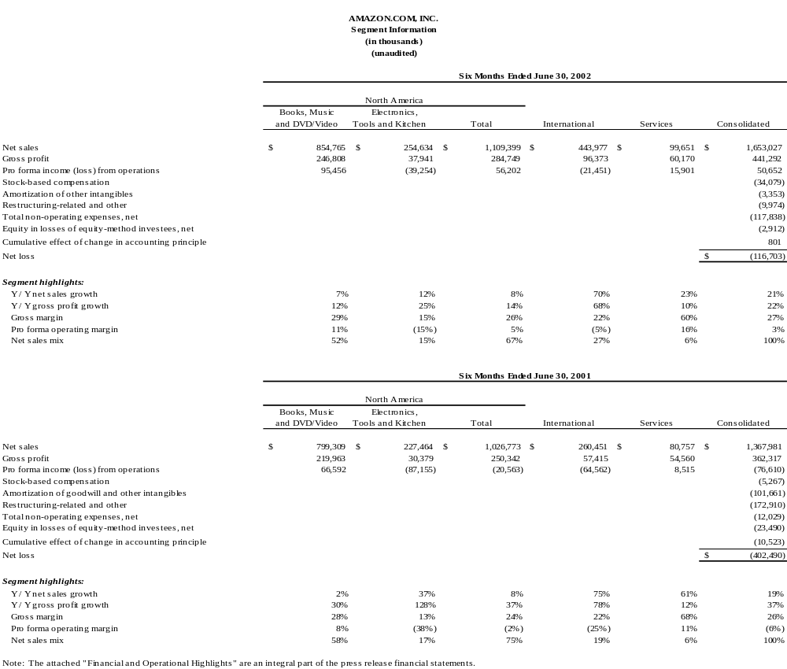
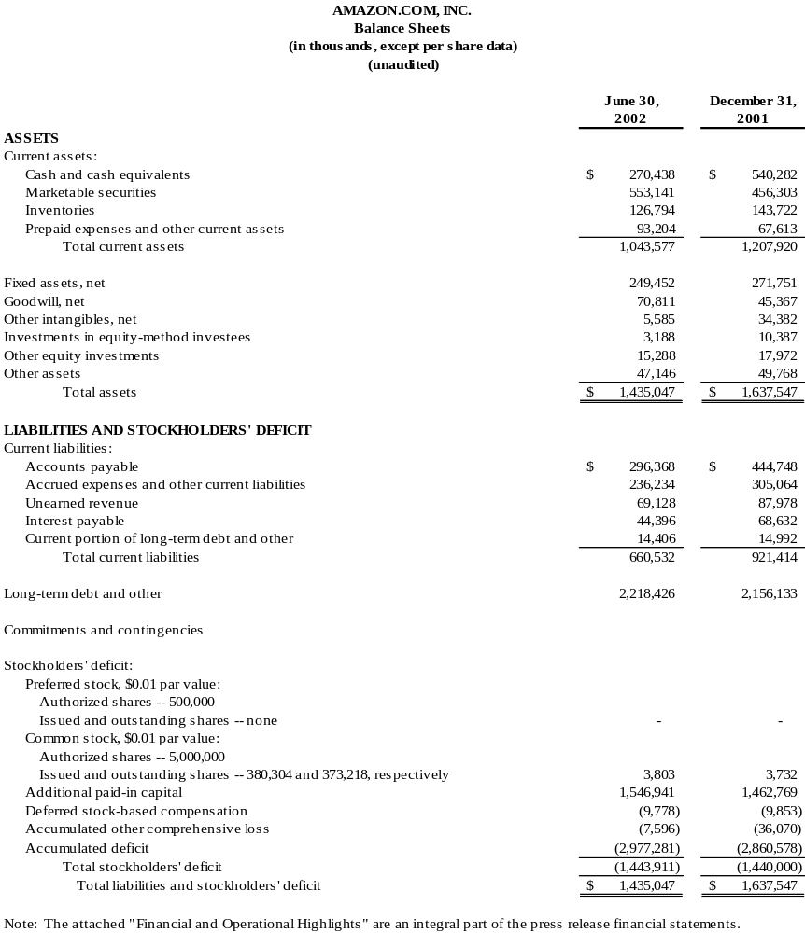
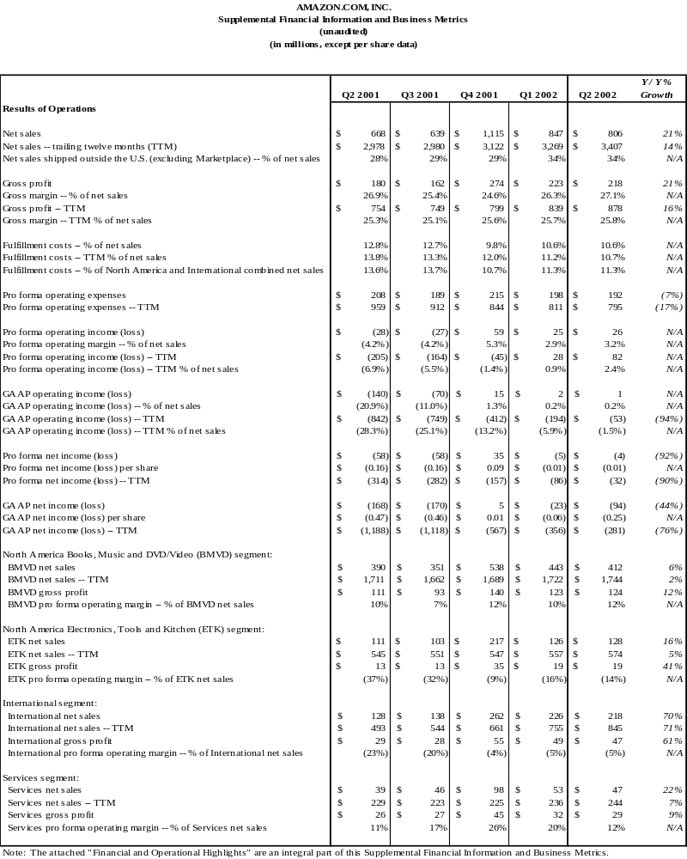
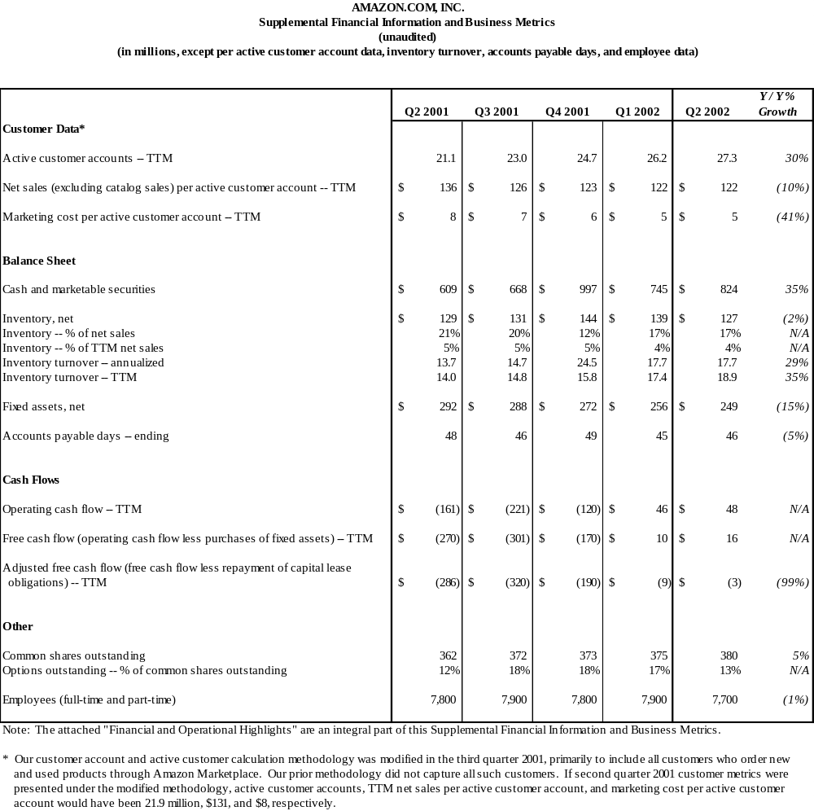

AMAZON.COM, INC.
Financial and Operational Highlights
Second Quarter Ended June 30, 2002
(unaudited)

Results of Operations (all comparisons are with the equivalent period of 2001)

Net Sales

- The benefit to net sales from foreign-currency exchange rate fluctuations was less than $0.1 million.
- Shipping revenue, excluding commissions earned from Amazon Marketplace, was approximately $81 million, up from $76 million.
- Equity-based services revenues decreased to approximately $5 million from $8 million.

Gross Profit

- Shipping profit was approximately $2 million, improving from a loss of $2 million. We continue to measure our shipping results relative to their impact on our overall financial results, with the viewpoint that shipping promotions are an effective marketing tool. We expect to continue offering shipping promotions to our customers, which reduce shipping revenue as a percentage of sales and will negatively affect gross margins on our retail sales.

Fulfillment

- Fulfillment costs represent those costs incurred in operating and staffing our fulfillment and customer service centers, including costs attributable to receiving, inspecting and warehousing inventories; picking, packaging and preparing customers’ orders for shipment; credit card fees and bad debt costs; and responding to inquiries from customers. Fulfillment costs also include amounts paid to third-party cosourcers, who assist us in fulfillment and customer service operations. Certain fulfillment-related costs incurred on behalf of third-party sellers, excluding those costs associated with Syndicated Stores, are classified as cost of sales rather than fulfillment.

Stock-Based Compensation

- During the first quarter 2001, we offered a limited non-compulsory exchange of employee stock options, which results in variable accounting treatment for approximately 8 million stock options at June 30, 2002, including approximately 7 million options granted under the exchange offer with an exercise price of $13.375, and approximately 1 million options that were subject to the exchange offer but were not exchanged.
- Variable accounting treatment will result in unpredictable and potentially significant charges or credits, depending on the fluctuation in quoted prices for our common stock, which we are unable to forecast.
- Cumulative compensation expense recorded at June 30, 2002, associated with variable accounting was approximately $31 million—based on exercises to date and a quarter-end closing common stock price of $16.25—of which $11 million is associated with options exercised and no longer subject to future variability.
- We have quantified the hypothetical effect on stock-based compensation associated with various quoted prices of our common stock using a sensitivity analysis for our outstanding stock options subject to variable accounting. We have provided this information to give additional insight into the volatility we may experience in the future in our results of operations to the extent that the quoted price for our common stock is above $13.375. This sensitivity analysis is not a prediction of future performance of the quoted prices of our common stock. Using the following hypothetical market prices of our common stock above $13.375, and the actual expense associated with options exercised and no longer subject to future variability, our hypothetical cumulative compensation expense at June 30, 2002, and the difference between hypothetical cumulative compensation expense and actual cumulative compensation expense recorded at June 30, 2002, resulting from variable accounting treatment would have been as follows (in thousands):

Hypothetical Increase  Over $13.375 |  | Hypothetical Market  Price per Share |  | Hypothetical Cumulative Compensation Expense |  | Hypothetical vs. June 30, 2002, Cumulative Compensation Expense
5% |  | $14.04 |  | $16,463 |  | $(15,027)
10% |  | $14.71 |  | $21,161 |  | $(10,329)
15% |  | $15.38 |  | $25,858 |  | $ (5,632)
25% |  | $16.72 |  | $35,252 |  | $ 3,762
50% |  | $20.06 |  | $58,738 |  | $ 27,248

Amortization of Goodwill and Other Intangibles

As a result of our adoption of the full provisions of Statement of Financial Accounting Standards No. 141 and No. 142, during the first quarter we reclassified $25 million of other intangibles (comprising only assembled workforce intangibles) to goodwill and discontinued the amortization of our goodwill assets.

Restructuring-Related and Other

- In 2001, we initiated an operational restructuring plan to reduce our operating costs, streamline our organizational structure, consolidate certain of our fulfillment and customer service operations and migrate a large portion of our technology infrastructure to a new operating platform. As a result, we recorded restructuring and other charges of approximately $114 million in the first quarter 2001, $59 million in the second quarter and $9 million during the second half of 2001. The restructuring plan is complete, although estimates may be adjusted prospectively if necessary.
- During the first quarter 2002, we permanently closed our fulfillment center in Seattle and, in connection with our 2001 operational restructuring, we revised our sublease income estimates for our vacated Seattle-area office space. These items resulted in additional restructuring-related expenses of $10 million primarily associated with ongoing lease obligations.
- Cash payments resulting from the restructuring were $13 million in the second quarter 2002, compared with $11 million. The restructuring charges are anticipated to result in the following net cash outflows (included within accrued expenses and other current liabilities and long-term debt and other on our balance sheet):
(in thousands) | Leases (a) | Other | Total
Six Months Ending December 31,
2002 | $12,438 | $3,677 | $16,115
Year Ending December 31,
2003 | 6,410 | 3,037 | 9,447
2004 | 2,761 | — | 2,761
2005 | 2,770 | — | 2,770
2006 | 3,036 | — | 3,036
Thereafter | 10,909 | — | 10,909
Total estimated cash outflows | $38,324 | $6,714 | $45,038

(a) Net of anticipated sublease income of approximately $59 million on gross lease obligations of $97 million.

Other Income (Expense), Net

- Other income (expense) consists primarily of net realized gains and losses on sales of marketable securities and disposals of fixed assets, miscellaneous state and foreign taxes and certain foreign-currency-related transaction gains and losses.

Other Gains (Losses), Net

- Other losses, net were $63 million for the second quarter 2002, and primarily consist of a $71 million foreign-currency loss on the remeasurement of our 6.875% convertible subordinated notes from Euros to U.S. dollars and a $10 million net gain on sales of equity investments.
- We are unable to forecast the gains or losses associated with our 6.875% convertible subordinated notes that will result from fluctuations in foreign exchange rates in future periods.

Earnings per Share

- Basic and diluted earnings per share is computed using the weighted average number of common and common stock equivalent shares outstanding during the period; common stock equivalent shares, such as options (outstanding employee stock options were approximately 50 million, compared with 42 million), warrants and convertible securities, were excluded from the computation because their effect is antidilutive.
- If the effect of common stock equivalents had been included, the number of shares used in the computation of diluted loss per share would have been approximately 399 million, compared with 376 million.

Financial Condition

- Cash and marketable securities are impacted by the effect of quarterly fluctuations in foreign-currency exchange rates, particularly the Euro. Our Euro investments, classified as available for sale, had a balance of 58 million Euros (approximately $58 million, based on the exchange rate as of June 30, 2002).
- Our marketable securities, at estimated fair value, consist of the following, as of June 30, 2002 (in thousands):
Asset-backed and agency securities $371,010
Treasury notes and bonds 108,051
Commercial paper and short-term obligations 29,800
Certificates of deposit 20,663
Corporate notes and bonds 16,885
Equity securities 6,732
$553,141
- We have pledged approximately $124 million of our marketable securities as collateral for certain contractual obligations, compared with $167 million as of December 31, 2001. Amounts pledged for standby letters of credit that guarantee certain contractual obligations, primarily property leases, were $56 million; $28 million is pledged for a swap agreement that hedges the foreign-exchange-rate risk on a portion of our 6.875% convertible subordinated notes; and $40 million is pledged for certain of our real estate lease agreements. The amount of marketable securities we are required to pledge pursuant to the swap agreement fluctuates with the fair market value of the swap obligation.

Certain Definitions and Other

- Our segment reporting includes four segments: North America Books, Music and DVD/Video (“BMVD”); North America Electronics, Tools and Kitchen (“ETK”); International; and Services.
- Allocation of centrally incurred operating costs methodologies have been consistently applied and there are no internal transactions between segments.
- The BMVD segment includes revenues, direct costs and cost allocations primarily associated with retail sales from www.amazon.com and www.amazon.ca for books, music, DVDs, video products and magazine subscription commissions. This segment also includes commissions and other amounts earned from sales of these products, new or used, through Amazon Marketplace and revenues from stores offering these products through our Syndicated Stores Program, such as www.borders.com.
- The ETK segment includes revenues, direct costs and cost allocations primarily associated with www.amazon.com retail sales of electronics, computers, kitchen products and housewares, camera and photo items, software, cell phones and service, tools and hardware, and outdoor living items, as well as catalog sales of toys and tools and hardware. This segment also includes commissions and other amounts earned from sales of these products, new or used, through Amazon Marketplace and from offerings of these products by third-party sellers under our Merchant@amazon.com Program, such as Target and Circuit City.
- The International segment includes all revenues, direct costs and cost allocations associated with the retail sales of our German, French, Japanese and U.K. Web sites--www.amazon.de, www.amazon.fr, www.amazon.co.jp and www.amazon.co.uk. This segment also includes commissions and other amounts earned from sales of products, new or used, through Amazon Marketplace and revenues from stores offering these products through our Syndicated Stores Program.
- The Services segment includes revenues, direct costs and cost allocations associated with our business-to-business commercial agreements, including the Merchant Program, such as www.target.com beginning third quarter 2002, and, to the extent full product categories are not also offered by our online retail stores, the Merchant@amazon.com Program, such as Toysrus.com. This segment also includes our technology alliance with America Online and miscellaneous marketing, promotional and other agreements.
- All references to customers mean customer accounts, which are unique e-mail addresses, established either when a customer’s initial order is shipped or when a customer orders from certain third-party sellers on our Web sites. Customer accounts include customers of Amazon Marketplace, Auctions and zShops services and from our Merchant@amazon.com and Syndicated Stores Programs, but exclude Merchant Program customers, Amazon.com Payments customers, our catalog customers and the customers of selected companies with whom we have strategic marketing and promotional relationships.
- Trailing twelve-month net sales per active customer account figures include all amounts earned through Internet sales, including net sales earned from new or used products sold through Amazon Marketplace, Auctions and zShops services, and products sold through our Merchant@amazon.com and Syndicated Stores Programs, but excluding products sold through our Merchant Program, catalogs and certain strategic alliances and sales of inventory to Toysrus.com. A customer is considered active upon placing an order.

